DATA GOVERNANCE MANUAL

This document outlines the purpose, structure, goals, participants and responsibilities of the organization’s data governance program. This document should be disseminated throughout the agency and given to new employees during the on-boarding process. It should be updated annually.

Contents
Introduction 3
Mission and Vision 4
Data Governance Policies 5
Data Governance Structure 5
Decision Process 6
Guiding Principles 7
Goals 7
Key Roles 8
State Superintendent of Public Instruction 8
Chief of Staff 8
Educational Data Management Office 9
IT Strategist 9
Data Governance Coordinator 9
Data Owners 9
Data Stewards 9
Data Stakeholders 10
Data Governance Structure: Tiers, Responsibilities and Objectives 10
[Include the responsibilities and objectives as well as a brief description of each data governance committee.] 10
Example: Superintendent and Cabinet 10
Data Governance Board (DGB) 10
Data Stewards Workgroups 10
External Advisory Committee 12
Data Governance Meeting Schedule 12
[Insert the meeting schedule for each of the data governance committees.] 12
Example: Superintendent’s Cabinet 12
Data Governance Board 12
Data Stewards Workgroups and External Advisory Committees 12
Appendix A. What Data Governance is Not 13
Appendix B. Data Steward Responsibility Areas 13

Introduction

[Include an introduction that explains the context for data governance at your organization and describes the scope of DG at your organization.]
Example:
The Oklahoma State Department of Education’s (OSDE) data governance program is an internal operational function that supports decision making by leaders at all levels within OSDE. The data governance process is applicable to all processes and systems that collect, analyze, disseminate and store data; and includes anything that affects the agency’s ability to perform these functions. The ability of OSDE to use data for decision making is reliant on the availability, usability, integrity and security of the data. A shortfall in any of these areas will degrade decision-making capabilities.

According to The Data Governance Institute, “Business needs drive information needs, which drive technology strategies and approaches.” But what does this really mean? Business needs are the tasks done everyday to support school districts, teachers and students. The business need may be distributing funds, processing grants, or developing future legislation. Each of these business needs has an information need: to know something so the right decision can be made. And how that something is learned drives the technology so that the information is received in a format that is accurate, usable and relevant to the business need or problem for which a solution is being developed.

OSDE is a complex agency and identifying the information requirements of its stakeholders and then delivering the data is challenging. The needs and the focus will vary among the various stakeholder groups. Data governance is the process that matches stakeholder needs with the appropriate data owner(s) within the agency to provide the right information. Data governance also serves to coordinate the overlap between the business functions of OSDE and the information technology functions of OMES. The collaboration between OSDE and OMES creates an enterprise solution for stakeholders, not simply an agency solution.

An effective data governance program brings an enterprise-wide focus to data-related matters and ensures that division or process-specific silos do not exist without consideration of their role within the larger system. OSDE manages data governance as an enterprise-wide program rather than as a series of disconnected, one-off projects.

Data governance provides and enforces enterprise-wide data standards, common vocabulary, reports, and the development and use of standardized data. It enables OSDE to more easily integrate, synchronize and consolidate data from different OSDE divisions. In addition, it facilitates the exchange of data with other agencies and organizations in the state (as legally required or permissible) in a consistent format, allowing for better and more secure communication through shared or known terms and report layouts.
Effective data governance makes the agency more efficient by reducing costs, establishing accountability, ensuring transparency and building standard, repeatable processes regarding data activities and communication. To do so, however, the data governance program requires active and ongoing participation and commitment of executive leadership, business owners, enterprise data management, federal program areas and IT, as well as consultation with external education stakeholders.
In order for its data governance program to be effective and to accomplish the agency’s mission, the state superintendent of public instruction and the executive cabinet must ensure personnel, policies, procedures and organizational structures are in place to make data accurate, consistent and secure.

Mission and Vision
[Insert the organization’s data governance mission and vision.]
Example:
Mission. To ensure that the highest quality data are collected, analyzed and made available to key stakeholders through coordinated efforts for the purposes of improving efficiency, protecting privacy and enabling better decision making by policymakers and educators.

Vision. OSDE benefits from using governance to define and implement a robust information management system that meets existing and long-term needs of both internal and external stakeholders. Key aspects of a strong information management system include:

- Data Management – identify essential data elements to be used in local, state and federal reporting requirements; define and standardize those elements for reliable and valid use across districts and in multiple reports; and design and deploy effective and efficient collection and storage processes that ensure security, privacy and appropriate integration across programs and from multiple data sources.

- Technology – identify and implement efficient and state of the art technological solutions that ensure easy integration, interoperability, privacy, secure access and easy analyses.

- Valid and Reliable Analyses – Provide controlled access and use, particularly by OSDE staff, that enables timely, reliable and valid analyses to prepare state and federal reports and conduct necessary continuous improvement program evaluations that support increased student achievement.

Data Governance Policies
[If your organization has a formal data governance policy, include it here. Otherwise, include a statement describing the role of data governance policies in your organization.]
Example:
The data governance policies serve as the backbone of the data governance program and ensure that the governing of data is not optional. The state superintendent of public instruction will approve all data governance policies that best support the OSDE data systems and protect student privacy. The superintendent will make recommendations to the governor and State Board of Education as required by law.

Data Governance Structure
[Describe your organization’s data governance structure.]
Example:
The OSDE’s data governance program is planned, managed and implemented through a three-tiered structure under the leadership of the state superintendent of public instruction who has ultimate review and decision-making authority. Each tier consists of individuals and processes that address student privacy, data quality, data management, data policies, business process management and risk management surrounding the handling of data. Each tier has clearly outlined responsibilities for implementing and enforcing policies and guidance involving data (see figure below).
Issues, policy and solution recommendations escalate up through this structure to the state superintendent; implementation flows down from the state superintendent to the Data Governance Board (DGB) and then to the data stewards workgroups as necessary.
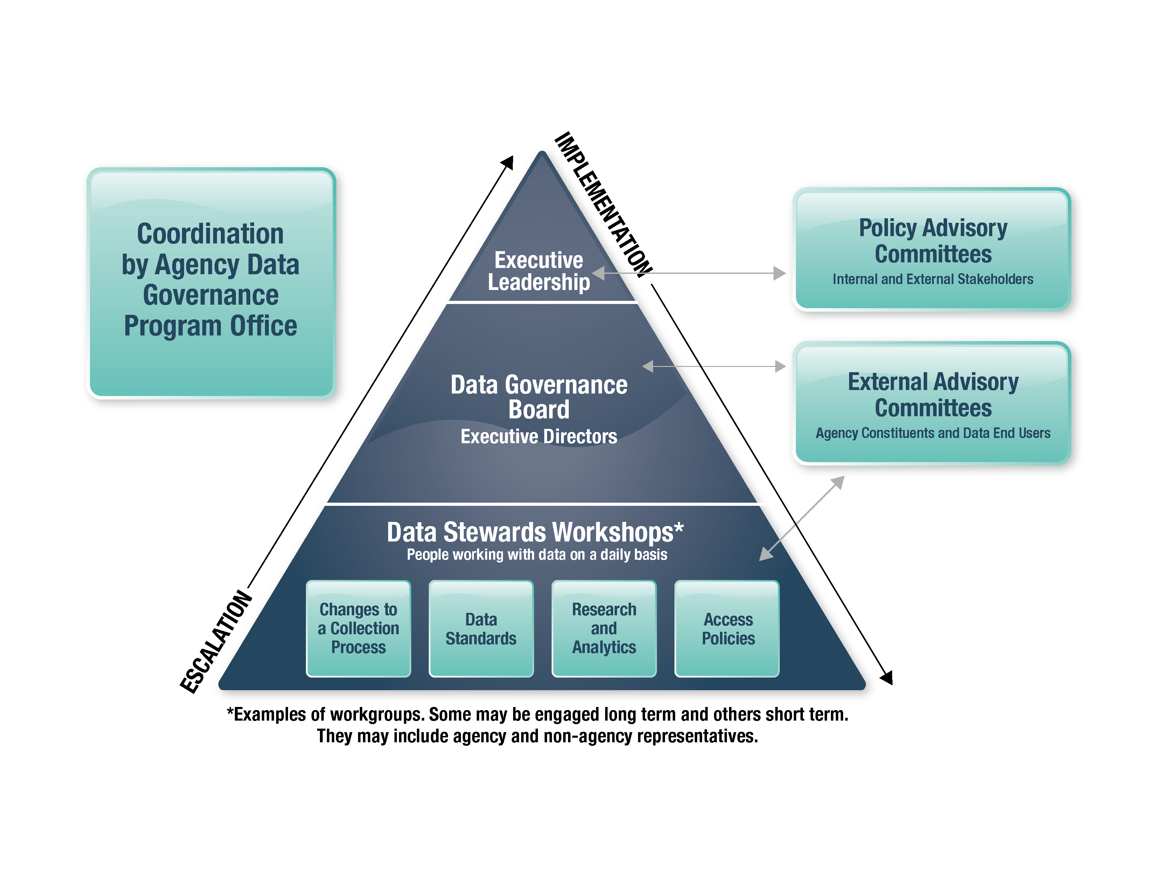

Decision Process

[Describe your organization’s decision-making process within the data governance structure.]

Example:
While ultimate authority and responsibility lie with the superintendent, data governance decisions involve many people.

- The cabinet and the DGB advise the superintendent.
- Input is received from local and statewide stakeholders (e.g., districts, legislature, and SBOE) as needed.
- Data owners and data stewards are responsible for determining necessary changes for compliance with state and federal mandates or superintendent rulings, and for making recommendations through the governance structure.
- Data steward workgroups convene as needed to troubleshoot and find potential solutions for data issues and make detailed recommendations to DGB.
- The superintendent will advise the legislature and SBOE as required, particularly when new data collections are warranted.
- Local education agencies (LEAs) are required to meet state reporting requirements, but are required to procure their own data system hardware, software and decision support systems.

Guiding Principles

[Insert the organization’s data governance guiding principles.]

Example:
- Ethics and security will be a part of every decision the group makes.
- Student privacy will be a primary consideration for all decisions.
- Members are empowered to make policy recommendations from an agency-wide perspective.

Goals

[Insert the organization’s data governance program goals.]

Example:
OSDE has several goals that must be met in the near-term to position the agency to meet its mission. These goals will be the data governance program’s initial focus and all effort and resources will be directed toward their successful completion.

- Student Data Privacy. Protect the privacy of student data. Identify and label all data elements that contain personally identifiable information (PII). Create efficient and effective policies around data access, data use and data release.

- Data Accessibility. Provide appropriate access to data across OSDE. Create policies and procedures that give OSDE staff appropriate access to data based on job function, while maintaining compliance with state and federal law.

- Data Content. Understand all of the data collected and used by OSDE. Each program area should gain a better understanding of its respective data through the process of documenting it in the DataSpecs tool.

- Application Use. Increase capacity for extracting data from existing applications. Program areas should understand the functionality of the applications they use to collect data. This includes gaining the ability to extract data from those applications for the purposes of producing reports by using queries.

- Data Manipulation. Reduce reliance on OMES and increase OSDE’s capacity to manipulate data. Provide training to OSDE staff in order to expand the ability to query, sort, filter, organize and present data that meets the needs of stakeholders.

- Data Definitions. Define every data element collected by OSDE. Create a consistent format for data definitions and create a definition for every data element collected by OSDE that is clear and consistent with the chosen format.

- Data and IT Strategic Plan. Create a data and IT strategic plan and communicate it across the agency. Executive leadership should create a plan that clearly outlines the goals for and path toward improving OSDE’s data and IT initiatives.

- Resource Management. Prioritize and increase transparency around the use of IT resources. Develop consistent processes for initiating new projects and enhancements and for governing data collection and dissemination. Include all OSDE staff in these processes in order to properly track resources and create transparency around their use.

- Business Rules. Establish business rules that ensure all of OSDE’s data conforms to identified standards of quality, consistency and shareability. Develop, document, publish and implement business rules that clearly outline actions and constraints around creating, updating, deleting and distributing data.

- Data, Technology and Information Flow. Articulate the flow of data, technology and information within the agency. Create and make public a data system diagram that illustrates the flow and use of data and information between systems and program areas throughout the agency. Additionally, document how all data collections are created, updated, managed and integrated; how technology is managed cooperatively between OSDE and OMES; and how information is derived from data.

Key Roles

[Describe the key roles involved in the organization’s data governance program.]

Example:
While everyone within OSDE is responsible for appropriately participating in data governance, individuals or groups with key roles include:

State Superintendent of Public Instruction
The state superintendent holds the ultimate decision-making authority over data, technology and information systems, including the data governance program.

Chief of Staff
The chief of staff is the superintendent’s designee to coordinate and synchronize the development of the data, technology and information systems and structure to effectively support OSDE’s strategic plan. This ensures that all actions within the data governance process are aligned to support the agency and stakeholder and ultimately provide a positive impact on teaching and learning in the classroom.

Educational Data Management Office
The educational data management office (EDMO) is made up of data coordinators and analysts each of whom has expertise in and works closely with particular program areas within OSDE. The purpose of the EDMO is to bring each of those areas of expertise together to develop a complete understanding of the OSDE’s data and system architectures and to ensure interagency coordination of data collection and use. The data coordinators and analysts are the agency’s over-arching data experts and are integral to the data governance program. The data coordinators and analysts are responsible for participating alongside program area data stewards in workgroups designed to address specific data-related issues. In addition, the EDMO serves as the conduit between OSDE departments (content specialists in specific program areas) and OMES IT developers and programmers.

IT Strategist
The IT strategist is an OMES position that provides technical expertise and guidance to the data governance program. This position is integral to ensuring the synchronization of the data requirements and business practices with the IT systems and applications. This mutual understanding of capabilities and requirements assists in the development of systems that fully support the business requirements and prevents the misuse of IT resources. This collaboration between OSDE and OMES in the data governance process provides for the best IT solutions at the lowest cost at the right time.
Data Governance Coordinator
The data governance coordinator is responsible for coordinating the data governance program and its activities and facilitating the DGB and data stewards workgroup meetings. This includes providing support to all committees, drafting data governance documents, disseminating materials and information and coordinating certain data-related initiatives such as documenting metadata and refining data-related processes and procedures. The data governance coordinator serves as the conduit to the chief of staff who reports to the superintendent and provides the cabinet with status reports, recommendations from the DGB, and escalated data issues that cannot be resolved by the DGB. In addition, the data governance coordinator manages data governance goals and action items and documents policies and processes.
Data Owners
Data owners are executive and program directors at OSDE who serve on the DGB. They are the individuals within the agency ultimately responsible for defining, collecting, protecting and providing access to data.
Data Stewards
Data stewards are employees in program areas that work directly with data. They are subject matter experts and the most knowledgeable authorities on data and program-specific database systems as well as the business processes that use the data. Data stewards also include OSDE and OMES data architects, database administrators and technical end users who work closely with data.

Data Stakeholders
OSDE has numerous stakeholders that require either student level or aggregate data sets. Some of the key stakeholders are:

- Legislators and Other Government Officials
- Oklahoma School Districts
- Parents and Students
- Research Institutions
- Higher Education Institutions
- CareerTech
- Other State Agencies
- Federal Agencies
- Media
- Special Interest Groups
- General Public

Data Governance Structure: Tiers, Responsibilities and Objectives

[Include the responsibilities and objectives as well as a brief description of each data governance committee.]

Example:
Superintendent and Cabinet
The superintendent has ultimate authority and responsibility over the data governance program. The superintendent, with the direct support of the cabinet, establishes the strategic vision and sets goals for the agency. They ensure that data governance is aligned with the strategic direction of the OSDE, ensuring that data governance efforts address all relevant and mission-critical needs of the enterprise. It manages data governance as an integrated program rather than as a set of unconnected projects. Finally, it recommends data governance solutions, priorities and policies to the state superintendent for approval.

Responsibilities of the Superintendent and Cabinet:
- Articulate mission and strategic goals of the data governance program.
- Secure the support, resources and cooperation needed to operate the program.
- Resolve problems and unresolved issues escalated from the DGB.
- Advise the state superintendent from an agency-wide perspective – or “enterprise perspective” – that is based on what is best for the organization as a whole instead of what is merely desirable for a given division or program area.
- Ensure that each division and office is represented on the DGB and regularly attends and participates in the meetings of these two committees.
In situations where state statute requires review or approval of data governance decisions by the State Board of Education, the governor or the legislature, the state superintendent would submit a recommendation and supporting materials to those bodies for final decision making.
Data Governance Board (DGB)
The DGB develops implementation plans for agency policies. It proposes data governance solutions, priorities and policies to the cabinet for review and communicates with internal and external stakeholders. The DGB consists of executive directors and program directors – i.e., “data owners,” from across the agency – as well as the data governance coordinator and the IT strategist. The data governance coordinator identifies data owners for membership on the DGB. Individual cabinet members approve DGB memberships for their respective areas.
Responsibilities of the DGB:
- Resolve issues escalated from the data stewards workgroups.
- Escalate issues that cannot be resolved by the DGB to the cabinet.
- Review and recommend to the cabinet data-related policies and program-level decisions at the OSDE.
- Propose enhancement and project prioritization.
- Develop plans and processes for the implementation of agency data governance policies.
- Identify data stewards to oversee specific data elements.
- Communicate with internal stakeholders and key data users.
- Solicit input from the external advisory committees, external stakeholders or other data stewards as needed.
Objectives of the DGB:
- Achieve consistency in collecting and reporting data across various agency teams and source systems.
- Achieve high quality data in the OSDE’s collection, analysis and reporting.
- Respond in a timely manner to data issues that are escalated to the DGB.

Data Stewards Workgroups
In most cases, data stewards are staff already working closely with the data. OSDE will provide data stewards with the knowledge, tools, forums and processes to become effective and efficient in their roles.
The main responsibility of data stewards workgroups is to assist in managing OSDE data assets to improve their validity, accessibility and quality. Data steward workgroups address a specific data-related issue, work with the DGB to continually improve agency data flow and implement agency policy.
The data steward workgroups provide tactical-level implementation of the OSDE’s data-related policies, analyzes any tactical problems that arise, advises and receives assignments and priorities from the DGB and resolves technical issues. The data steward workgroup members outline the necessary components of the data governance initiative to meet the strategy as outlined by the cabinet and DGB. For instance, they do impact analyses to determine how changes in specific data sets will affect program areas and help resolve data quality problems. Data owners identify data stewards for participation in data steward workgroups and provide those names to the data governance coordinator.
If a development project identifies data problems, the data stewards invite an IT representative of the project either to (a) discuss the problem and its possible solutions, or (b) help with research and review of the issues at hand. The workgroup forwards recommendations to the DGB for review and discussion. Once consensus on a recommended solution is achieved by the DGB, the proposal is submitted to the superintendent and cabinet for review and approval.
Responsibilities of the Data Stewards:
- Manage the definition, production, accountability and usage of data.
- Focus on maximizing data quality and efficiently managing the data enterprise-wide, not solely within one’s division.
- Provide data analysis related to his/her specific program area.
- Evaluate data quality.
- Identify opportunities to share and re-use data.
- Enforce data quality standards.
- Identify and help to resolve data quality issues, such as integrity, timeliness, accuracy, completeness, etc.
- Escalate issues, as necessary, to the DGB.
- Communicate new and changed data requirements, business needs for data security and criteria for archiving data to necessary individuals.
- Implement federal and state legislation involving data elements and reporting requirements, including reviewing federal register notices, at the direction of the state superintendent.
- Share tools and resources.
- Support the data owner who is accountable for making sure the designated data stewards carry out responsibilities.
- Foster an environment of learning and sharing expertise in relation to data stewardship throughout the agency.
- Solicit input from the external advisory committees or other data stewards as needed.
Data Steward Objectives:
- Improve accountability for data accuracy.
- Attain a “single point of truth” for data (identify the “master” source of data, who is the true “owner” of data and minimize redundancy in data collection).
- Improve productivity by having a central and efficient electronic data reporting process in place.
- Improve reusability of data.
- Improve understanding of data.
- Improve reporting capability and timeliness of reporting.
- Improve data quality in order to reduce the cost of work efforts in relation to data clean up and analysis.
- Improve understanding and communication with appropriate OSDE staff about any federal and state legislation that will impact OSDE data.
External Advisory Committee
The three-tiered governance structure outlined above requires engagement and support from other critical stakeholders. Effective and frequent communication is essential for successful data governance and requires that executive leadership and the DGB tell stakeholders what steps are being taken and why, and inform all relevant stakeholders about how data governance benefits them. In addition, it is necessary to incorporate their ideas and feedback into proposed solutions to technical and data issues; the planning, design and review process; and potential data system changes. Input and feedback from all stakeholders make governance efforts more effective in achieving mission-critical goals and are vital for successful data governance. Such engagement also encourages cooperation with the inevitable changes that data governance requires, whether they are changes in work processes or they are as simple as adapting to standard data formats and terminology.

Data Governance Meeting Schedule
[Insert the meeting schedule for each of the data governance committees.]
Example:
Superintendent’s Cabinet
Governance items will appear on the superintendent’s cabinet agenda as determined by the superintendent and the chief of staff.
Data Governance Board
The DGB meets the third Wednesday of every month at 1:00 p.m. Meetings are facilitated by the data governance coordinator.
Data Stewards Workgroups and External Advisory Committees
The data stewards workgroups and external advisory committees meet on an ad hoc basis. Meetings are organized and facilitated by the data governance coordinator.

[Include appendices as needed.]

Example appendices:

Appendix A. What Data Governance is Not
Understanding what data governance is not can help focus on what it is.
Data governance is NOT:
- Data cleansing or extract, transform and load data (ETL).
- Data warehousing.
- Database design.
- Project management.
While each of these is affected by or related to the data governance program, data governance addresses more than these disciplines and each of these areas has facets beyond data governance, such as technological and architectural solutions.

Appendix B. Data Steward Responsibility Areas

Federal Reporting (EDEN/EDFacts):
- Identify and record EDEN/EDFacts metadata documentation such as business rules, transformations and source information.
- Confirm that source data is ready for extract to EDEN repository.
- Spot-check data transformations in EDEN repository.
- Verify data accuracy of EDEN/EDFacts files.
- Work with EDFacts coordinator and programmer to resolve any data quality issues.
- Submit data (or request that data be submitted) to EDEN/EDFacts.

External Data Requests:
- Support the Office of Legal Services as requested in preparing and publishing/releasing data.
- Assist in determining the best source to fulfill data requests.
- Assist in determining if data/report already exists and can be utilized.
- Communicate with the data owner about data from their program area being sent outside of the OSDE, as necessary depending on customer and data.

Enterprise Data Management:
- Identify and record enterprise-wide metadata such as business rules, transformations and source information in OSDE metadata repository.
- Confirm that source data are ready for ETL (extract, transform and load) to the data warehouse.
- Participate in the data quality and validations activities related to Wave/SLDS reports for historical and ongoing data loads.
- Participate in the establishment and validation of quality metrics for internal and public reports.
- Provide input as requested for the development and use of data marts and/or public reports.
- Be aware of any data marts, aggregations or other public reports utilizing the specific program area data.

Source Collection Systems:
- Assist in evaluation of source system enhancements based on data quality issues.
- Monitor functionality of systems to ensure needs are being met.
- Escalate issues and communicate with owner when necessary.
- Act as subject matter expert for enhancement and development projects.

Non-Wave Collections:
- Review existing Wave and non-Wave collections to determine if data is already collected in another collection; make suggestions for how existing data might be used instead.
- Participate in the establishment and validation of quality items and metrics to be used in non-Wave collections.
- Determine if data received in non-Wave collections meets established quality and validation metrics before use by OSDE or outside entities.

